Chang Liu, Chunyi Cui, Mo Sriha, Sai Chitti, Xin Yuan

CARNEGIE MELLON UNIVERSITY

Diet Analysis Cloud System Report for UPMC

Team 4

Table of Contents

Executive Summary3

Status in quo3

Review of Technology6

Solution9

Cost analysis18

Conclusion21

Reference 22

Appendix 24

Design document25

**Executive Summary**

The report focuses on the development of a diet analysis cloud system. We are using cloud services to analyze and evaluate a client’s lifestyle choices. Instead of the traditional method of deploying applications on our own servers, we let cloud providers manage our code execution - this is known as serverless computing. After a careful investigation of the current cloud platform providers, we decided to choose Amazon Web Services (AWS) as our system platform. To enhance the accuracy of our predictions, we had decided to augment the system’s image recognition segment with Google Cloud Vision.

All the clients shall wear portable cameras to record their meal, and these food images will be the input to our system. The image data will automatically be sent to our S3 bucket on AWS. This upload will trigger a function that we had put in our service, and at this point, the system starts to run automatically. This function will call three APIs - Machine Learning Rekognition (image tagging service provided by AWS), Google Cloud Vision (image recognition technology by Google), and Nutritionix (nutrition database API which includes nutrition data of common food items; that can provide us with detailed nutritional facts of the label that we get from Rekognition and Vision APIs). After calling these three APIs, the scores go through a scoring system where we designed an algorithm based on the nutritional data. The output of this system is a health indicator, and the same can be seen in the form of a chart. Customers can see their diet status and get a better understanding of their meal. UPMC can monitor all the diet data of applicants and adjust their healthcare insurance policy.

**Status in quo**

**Problem**

In the United States, the cost on health care is rising every year. In 2016, $3.4 trillion was spent on health care and this number will rise to $5.5 trillion by 2025 according to the study from Centers for Medicare and Medicaid Services. While health care cost $27.2 billion in 1960, which could be translated to an annual healthcare cost of $146 per person in 1960, this number is $10,523 per person in 2016.

The hike in the cost of health care services results in an increase in people’s health insurance costs. According to the study from Henry J. Kaiser Foundation and the Health Research and Educational Trust, health insurance has skyrocketed since 1999 to 2016. Since 1999, the premiums have risen nearly for a single worker rose over 280 percent, from $2196 to estimated $6435 in 2016(Figure 1). In the comparison to the inflation and worker’s earning rise, from 1999 to 2016, while the cumulative increase of workers’ earnings and overall inflation is 60% and 44% respectively, the increase of health insurance premiums has skyrocketed to 213%(Figure 2). In other words to say, every year people have to spend more proportion of their income on their health insurance.

However, of all total cost on health care, chronic illnesses such as hypertension, diabetes, high cholesterol, and heart diseases take a large account. These chronic illnesses are responsible for 85 percent of health care costs since almost half of all Americans have at least one of them and the treatment of these diseases is long-term and expensive. (Zane Benefits, 2014.) Also, chronic diseases can result in all of the four leading causes of death - heart disease, cancer, chronic obstructive pulmonary disorder, and stroke. For instance, Hypertension that can cause heart disease and stroke and obesity serves as a risk factor for the many common forms of cancer. (Kaiser Health News, 2011) As a result, the data shows that it is actually the sickest 5 percent of the population that contributes 50 percent of total health care costs. The most important is the fact that the healthiest 50 percent of people only contribute 3 percent of the nation's health care costs(The Daily Shot, 2017).

In reality, insurance companies rarely conduct profound and comprehensive health status background research when selling their insurance package. Usually people of the same age have the same premium. Therefore, healthy people always pay their premiums far more than they actually cost when they receive treatment in the hospital, which might only happen one or two times in a whole year. However, even they have a “good” record in the insurance company, the premiums of the following year would still go up because of their ages. Healthy people would buy their health insurance anyway since they do not want to have a risk if they encounter a major accident or illness. But actually, healthy people are paying the money for treatments of unhealthy people. It is absolutely not fair!

**Current solution and limitations**

Currently, UPMC has a set of deciding factors when selling its health insurance: (1) Gender, (2) Age, (3) Tobacco user (or not), and (4) ZIP code (to check which UPMC network can be used in the area). Putting aside the objective factors (from the above list) that don’t change, the only factor that takes people’s daily behavior into consideration is whether or not the person smokes. However, this factor solely does not serve as an appropriate parameter - It does not even look as accurate as age.

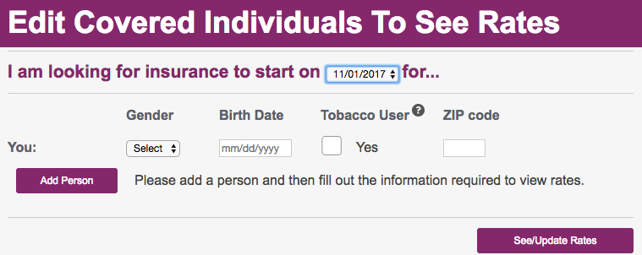

(Source: UPMC, 2017)

|  |  |  |  |
| --- | --- | --- | --- |
| Age | Gender | Tobacco User | Non-tobacco User |
| 40 | Male | 211.73 | 206.57 |
| Female | 211.73 | 206.57 |
| 45 | Male | 239.24 | 233.40 |
| Female | 239.24 | 233.40 |

When we test different people between ages 40 and 45 (tobacco users and non-tobacco users), the prices of premiums per month show that apart from the age factor, gender has zero influence on the price, and smoking behavior has only a subtle influence. But isn’t smoking one of the leading causes of deaths? Every year, cigarette smoking causes more than 480,000 deaths in the United States, that is nearly one in five deaths.

So UPMC’s current pricing criteria of its health insurance is far from effective to help people who lead a healthy live to reduce their premium. It does not take enough factors that relate to the everyday lives of people. Other questions to answer would be, how much weight do we need to give to the factor “smoking”?

We are here to help UPMC build a cloud computing system to monitor people’s everyday diet, and to come up with an evaluation of people’s health trend. If a healthy person can lead a healthy lifestyle every day, he or she can have a discount in the health insurance next year. This system can help UPMC keep its current healthy customers happy, attract more healthy people to buy their health insurance at UPMC, and also encourage people to lead a healthy life.

**Review of Technologies**

**Cloud Computing**

Cloud computing is the provision of computing power on demand, database storage, applications and other IT resources through the Internet through the cloud service platform at the price of pay-as-you-go. Whether you are running an application that shares photos to millions of mobile users or you are supporting business-critical services provided by the cloud service platform. You can have a quick access to flexible and low-cost IT resources. Using cloud computing, you do not need to worry about the hardware which normally needs a large investment, and, of course, you don’t need to spend a lot of time managing the hardware. Instead, you can just pay and get the correct type and size of resources as you need. Cloud computing provides a simple way to access servers, storage, databases, and extensive collections. In the cloud platform, UPMC can easily build the application they want without spending too much money.

**Amazon Web Services**

The AWS Cloud provides a broad set of infrastructure services, such as computing power, storage options, networking and databases that are delivered as a utility: on-demand, available in seconds, with pay-as-you-go pricing. This allows enterprises, start-ups, small and medium-sized businesses and public-sector customers to access block so that they can respond quickly to fluctuating business needs. Since Amazon Web Services began offering cloud computing services from 2006, it has been the undisputed leader in cloud market and will be for the foreseeable future.

**Lambda**

Most companies today develop applications and deploy them on servers — whether on-premises or in the cloud. That means figuring out how much server, storage and database power they need ahead of time, and deploying all of the hardware and software it takes to run the application, which is both expensive and time-consuming for UPMC to hire specific IT people to do this.

Amazon Web Services’ lambda service enables us to run our code without provisioning or managing servers. AWS Lambda executes our code only when needed and scales automatically. We can pay only for the compute time that we consume. AWS Lambda runs our code on a high-availability compute infrastructure and performs all of the administration of the compute resources, including server, capacity provisioning and automatic scaling, code monitoring and logging. Our code on lambda can be triggered in a variety of ways including other AWS services, HTTP endpoints, and mobile apps. Also, AWS supports some of the most mainstream languages including Node.js, Java, C# and Python, which gives us great flexibility. (*Amazon Web Services, Inc.*)

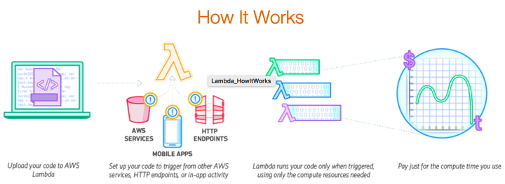

(Source: AWS Lambda - Serverless Compute.)

**APIs**

**-Amazon Rekognition API**

Amazon Rekognition is a service which provides the function of adding image analysis to applications. With Rekognition, we can detect objects, faces, labels and inappropriate content in images. It enables us to quickly add sophisticated machine learning-based image analyzation to our application. Besides, the API can easily be integrated seamlessly with Amazon S3, AWS Lambda, and other AWS service. (*Amazon Rekognition*)

**-Google Cloud Vision API**

Cloud Vision API allows developers to easily integrate vision detection features within applications, including image labeling, face and landmark detection, and tagging of explicit content. It provides us a RESTful interface (that quickly analyses image content) under which are actually continuously evolving machine learning models and image processing algorithms. It also provides cloud vision API client libraries to let us run it on local workstation and call Vision API to process images. The results from this API have relativity been more accurate for our project. (*Google Cloud Vision API Documentation*)

**-Nutritionix API**

Nutritionix provides us a nutrition database API with global API of nutrition data of common foods from USDA, 100k restaurant foods and food manufactures which basically covers almost all kinds of food we eat every day. The Nutritionix Track API can be combined with the v1.1 Nutritionix Branded Foods API to create a robust nutrition logging experience for health and fitness applications. It supports many programming languages including Java, Node, PHP, Ruby, etc., which give programmers great flexibility to develop applications based on Nutritionix API. (*Nutritionix*)

**Solution**

**Architecture**

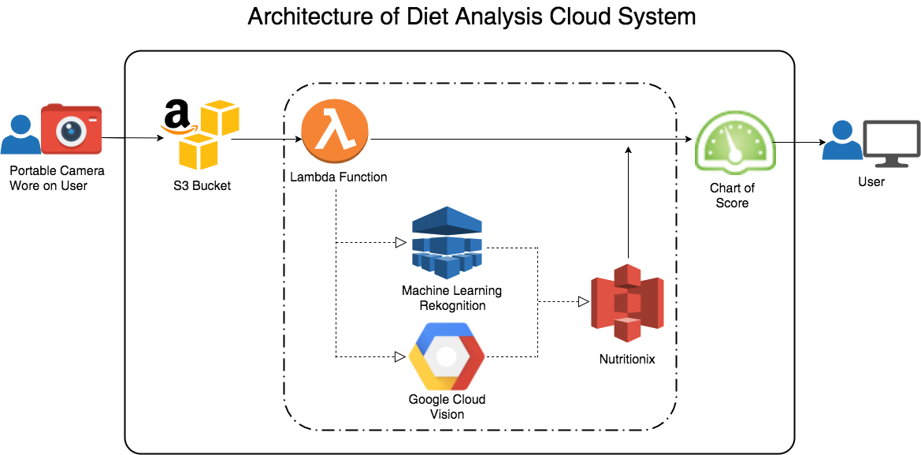

Users will wear a portable camera on their head while they are having their breakfast, lunch and dinner. The camera will take pictures of their foods and automatically upload to the s3 bucket. When there is an object created, the lambda function will be triggered. There are 3 APIs in our cloud system. To increase the accuracy of our system, we utilize both AWS Rekognition and Google Cloud Vision to detect the objects in the image. Then we use Nutritionix API to obtain nutrition facts of the labels generated by AWS Rekognition and Google Cloud Vision. The nutrition facts enable us to evaluate food and tell whether it is healthy or not and give a score accordingly. We are currently using a pie chart to show the properties of the food images. We are working on visualizing the score on a meter - that is, show the score on a scale ranging from “very unhealthy” to “very healthy” - to let the user get some insight into his food habits.

**Implementation of each part**

**-Bucket–to-bucket transfer**

Because we do not have the wearable cameras in our initial prototype, we have a simulated system that has images in a source bucket. The pictures of food are transferred from this public source bucket to our test bucket. Each public bucket can be looked at as a storage of pictures of one single user. This is the first step in our system - transferring the images from the source bucket (which would later be the camera). We developed a front-end web page for us to enter the concerned public bucket name. Once entered, and “Send” has been clicked, a random picture in that bucket will be pulled out and put into our own public bucket for later test and analysis.

This part is implemented via an HTTP request - the “GET” method. Once we click the button, it will link to a URL that contains the input name of the source bucket. The click action of that certain URL will trigger the service that can help to copy a random object in the source bucket to the destination bucket.

**-Machine Learning Rekognition & Google Cloud Platform Vision**

To have a more accurate analysis, we decided to use two APIs to help us identify the objects in the picture. These two APIs are put in our Lambda, which will be triggered by an event when a new object is created in the bucket. Once a new image is put in the bucket from the source bucket, AWS Rekognition and Google Cloud Platform will analyze the image and identify what things could possibly exist in it. APIs will respectively generate various labels with confidence in monitoring CloudWatch alarm log.

{u'Labels': [

{u'Confidence': 91.58039093017578, u'Name': u'Bread'},

{u'Confidence': 91.58039093017578, u'Name': u'Food'},  
{u'Confidence': 91.58039093017578, u'Name': u'Pita'},  
{u'Confidence': 63.08491134643555, u'Name': u'Bun'},  
{u'Confidence':62.56529235839844, u'Name': u'Biscuit'},  
{u'Confidence': 62.56529235839844, u'Name': u'Cookie'}]......

For example, the above is a sample result from AWS Rekognition: It means Rekognition estimates with a lot of confidence that the picture has bread, a kind of food, a pita, etc. These three are the likeliest things that could be in this image. The system gives around 60 percent confidence for ‘Bun’, ‘Biscuit’, ‘Cookie’. But won’t we lose credibility in image labeling? That’s exactly why we combine the two sets of labels that would be generated from AWS and GCP APIs together for further analysis.

To implement these two APIs in Lambda, first we need to do all the connection work to make sure that s3 will send a notification to Lambda when there is an object created in this bucket. Lambda will be triggered by this. After we put the code on Lambda and it ran successfully, we test again and again to analyze labels that it generates. Instead of manually tagging all the labels and generating an inaccurate lookup table, we came up with our third API - Nutritionix.

**-Nutritionix**

After observing the labels generated from Rekognition and Google Cloud Vision, we found some problems and difficulties.

Some of the labels we got were generic labels, many were not food labels like “bowl”, “fork”, “bottle” or some too general words such as “food”. Even given an accurate label, it is not easy for us to give the score. Tagging each label manually is not a smart way to go about things.

To solve the above two problems, we implemented our third API called Nutritionix to help us identify the nutritional content in the food image - a relatively reasonable and scientific way. When first two APIs output the labels, Nutritionix is triggered and starts its work. Since it will throw an exception if it detects non-food labels, we can filter those unrelated labels by setting the score for those label as zero. Also, Nutritionix can provide us with a detailed nutrition fact of the label in the following format, by which we can estimate whether it is healthy or not. Then we will give the score of each label based on its nutritional facts. For instance, food that contains a lot of sugar, sodium and cholesterol will be given a bad score. By analyzing based on nutrition facts instead of using common sense or other subjective methods, our result is far more objective, scientific and accurate.

**-Chart of Score**

After we get the score from Nutritionix on Lambda, we use a chart to visualize the data. This chart can be accessed by both users and UPMC. Users can see their diet status, and impose self-controlling rules on their everyday diet habits. If we find that the pie chart showing the user’s data is towards the unhealthy side, he/she will be reminded to eat more healthy food the next day. In the future, UPMC will be able to monitor their applicants with all this data in hand. If a healthy applicant enjoyed a discount on health insurance this year, and eats burgers, fries and ice cream the following year, even though he doesn’t have a serious illness yet, UPMC can stop offering the discount next year considering the possibility that the person might resort to bad food.

**Deployment of the solution on the cloud**

To deploy our system on the AWS cloud, we create a new S3 bucket to store all the images. Then we write code on Lambda, and with our function we call two APIs to analyze and get the labels of each image. The third API, Nutritionix (to translate those labels into nutrient content) is also embedded in the system. We designed an algorithm to calculate the score of that specific meal and then we send it to the UI so that users can see their diet status. In order to make our system run automatically after image is uploaded to our bucket, we added an event of object created to receive notification when a file is uploaded to our bucket. Also, we make our bucket as the trigger of our lambda function. Therefore, as long as an image is uploaded to our bucket our system can function robustly.

**Tests**

**-Unit Tests**

1. **Bucket to bucket transfer**

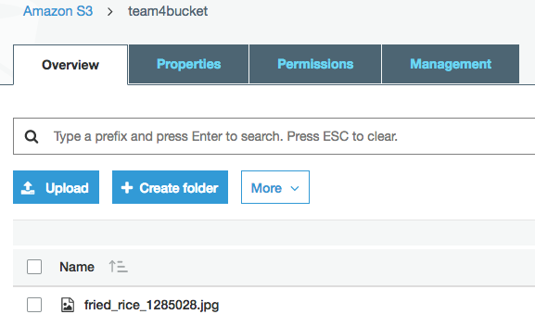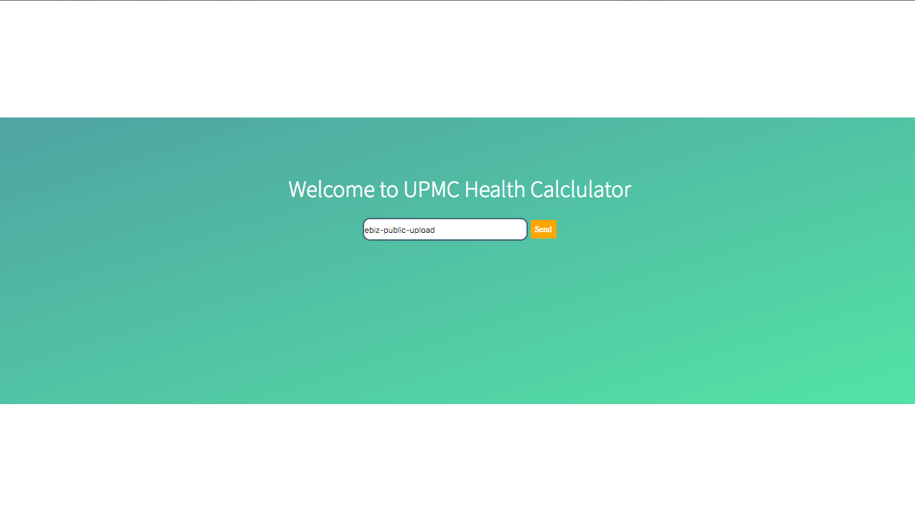

By inputting the name of the source bucket and clicking the button “Send”, one random picture from the source bucket will be sent to our bucket. So you can see from AWS s3 bucket, there is a new image created. Here, the source bucket can be any public bucket and since the bucket name is unique, we will not pull out wrong pictures from a wrong bucket.

1. **Lambda**

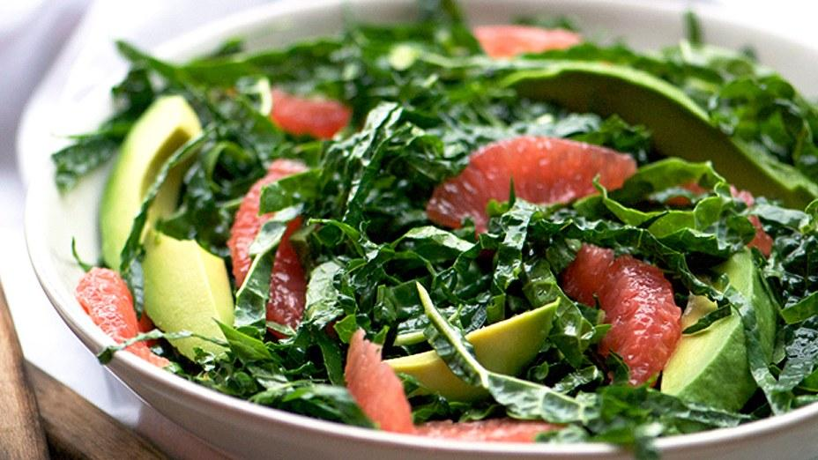

* dish
* salad
* leaf vegetable
* vegetable
* Produce
* Spinach
* Vegetable
* Food

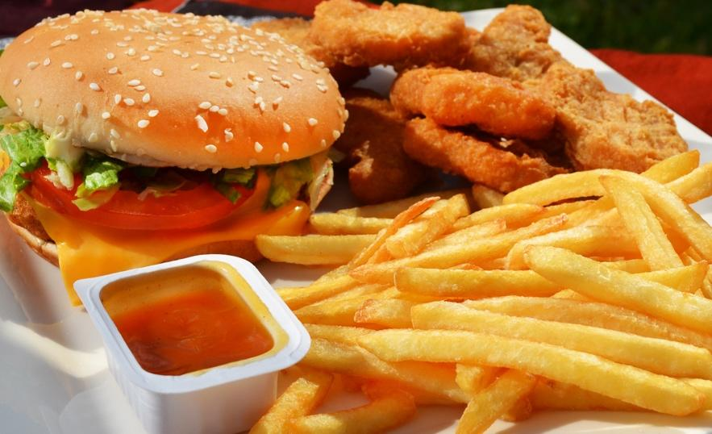

* french fries
* fast food
* fried food
* junk food
* Food
* Fries
* Bowl
* Burger

Our system can work very effectively. One picture of typical healthy food and one of typical unhealthy food are tested. These are labels generated from AWS Rekognition and GCP Vision API for a salad, and a mix of a burger, some fried chickens and fries. The system can almost identify all the main items in these two pictures. Even the one specifying the type of vegetable - “Spinach” - is caught.

**-Integration Tests**

For the integrated whole system, we need to visualize the results and show them to the user. So here are the final scores of the above salad and burger with fries. The higher the score is, the more unhealthy the meal is. As a result, the salad gets the score of 16 and the fast food gets a score of 98.

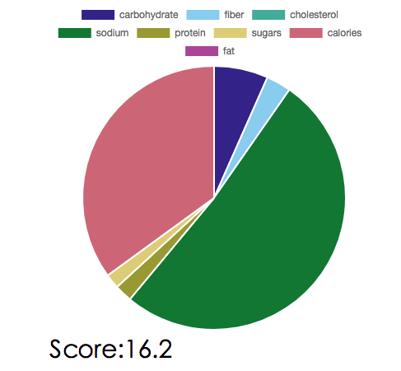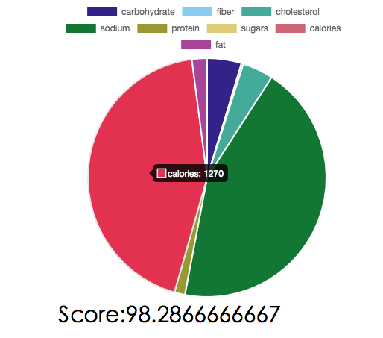

Moreover, when the user hovering up each area, the user can see the exact amount of nutrition in this food. In this way, this pie chart can help the user understand the nutrition facts in a vivid way. Users can find the amounts of calories, carbohydrates, sodium, sugar and all the 8 things in this meal. Therefore, the system will not only gives a general score of the meal, but can also help users to get to know deeply about the structure of their diet.

**Experiments**

We want to know what will happen if we put a food-related, but non-food picture into the system. We wanted to see if the system broke down or if it gave bizarre nutritional values to items like “forks”, “table”, etc. So we tested the following picture.



* dishware

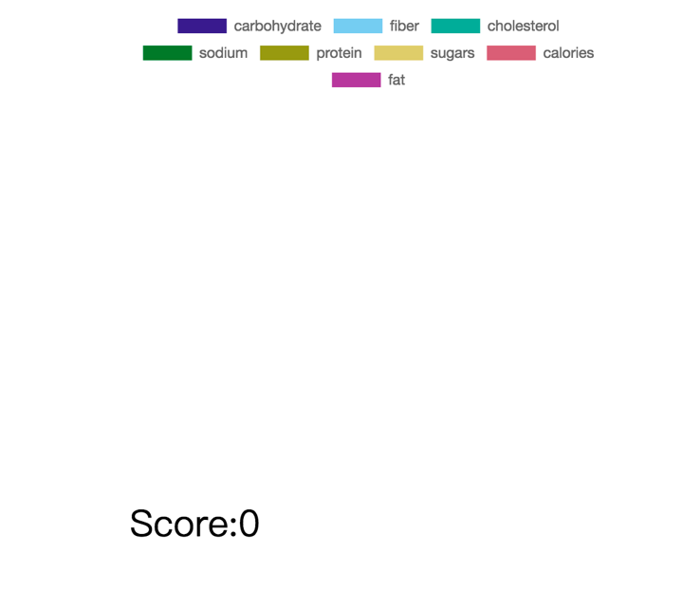 0

* fork

0

* cutlery

0

* porcelain

0

* Cutlery

0

* Fork

0

* Glass

0

* Dish

0

This is the result of the test for a non-food picture. Although Rekognition and Vision come up with non-food labels such as fork, cutlery or porcelain, the powerful API, Nutritionix is able to differentiate food and non-food labels. So we wrote a policy in the code saying if it is not food, we assign a score of zero. This can help the system get rid of the influence of non-food things that might be detected in the image.

**Limitation**

1. **Multiple Users**

Now although we can store historical data of the user to show the cumulative health status, we can only have one user to be tested in the current system. It will be a large improvement for us if we can upgrade the system and visualize their diets on one chart.

1. **Repeating Images**

Currently in the simulated system, when we send an image from the source bucket to our bucket, we randomly pull one of the images from the bucket to be sent. There is a possibility that we upload the same picture for analysis again, especially if there are only a few pictures in the source bucket.

**iii. Does not classify data**

Currently the system takes all the images and give the score on the same standards. But actually, the “healthy” standard for breakfast is not the same as dinner. A healthy breakfast should contain more carbohydrates and proteins while a healthy dinner should avoid taking too many carbohydrates, and fibers are highly encouraged. Therefore, one possible improvement for the system would be to classify images as “breakfast”, “lunch” and “dinner”.

**iv. Correlation between food taken and lifestyle**

The objective of the whole exercise is to be able to report to UPMC if the person under scrutiny has a healthy lifestyle or not. We try to determine that using only the food patterns of the individuals. Firstly, there are drawbacks in doing so in that the person could very well be eating unhealthy food away from our system’s camera. But more importantly, the lifestyle of an individual can’t be determined solely by the food they eat! Exercise, metabolism, age, the work they do everyday and their hobbies have to be incorporated into the system to get an overall idea of the person’s lifestyle.

**Cost Analysis**

In this part, we will do cost estimation and prediction based on 1000 users. Since we pay for what we use on cloud platform, the price will rise with the increasement of user.

**Cost of AWS service:113$/month**

1. **Lambda: 18.97$/month (including free tier)**

Request number 1000*3*30=90000/month

Allocated Memory： 128(MB)

Estimated Execution Time： 136731.33(ms)

Number of lambda function: 1

The Lambda free tier includes 1 million free requests per month and 400,000 GB-seconds of compute time per month.

(*AWS Lambda – Pricing.*)

1. **Bucket: 3.713$/month**

Upon sign-up, new AWS customers receive 5 GB of Amazon S3 storage in the Standard Storage class, 20,000 Get Requests, 2,000 Put Requests, and 15 GB of data transfer out each month for one year. We decided to use standard storage.

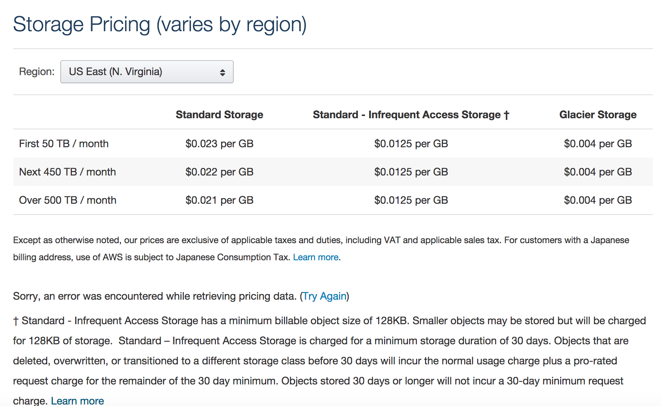

（Source: Cloud Storage Pricing – Amazon Simple Storage Service (S3) – AWS.）

storage for pictures: 1.5MB*90000=132GB

storage cost: (132-5) *0.023 = 2.921$/month

Request cost: (90000-2000) * 0.000005 + (90000-2000) * 0.000004 =0.792 $/month

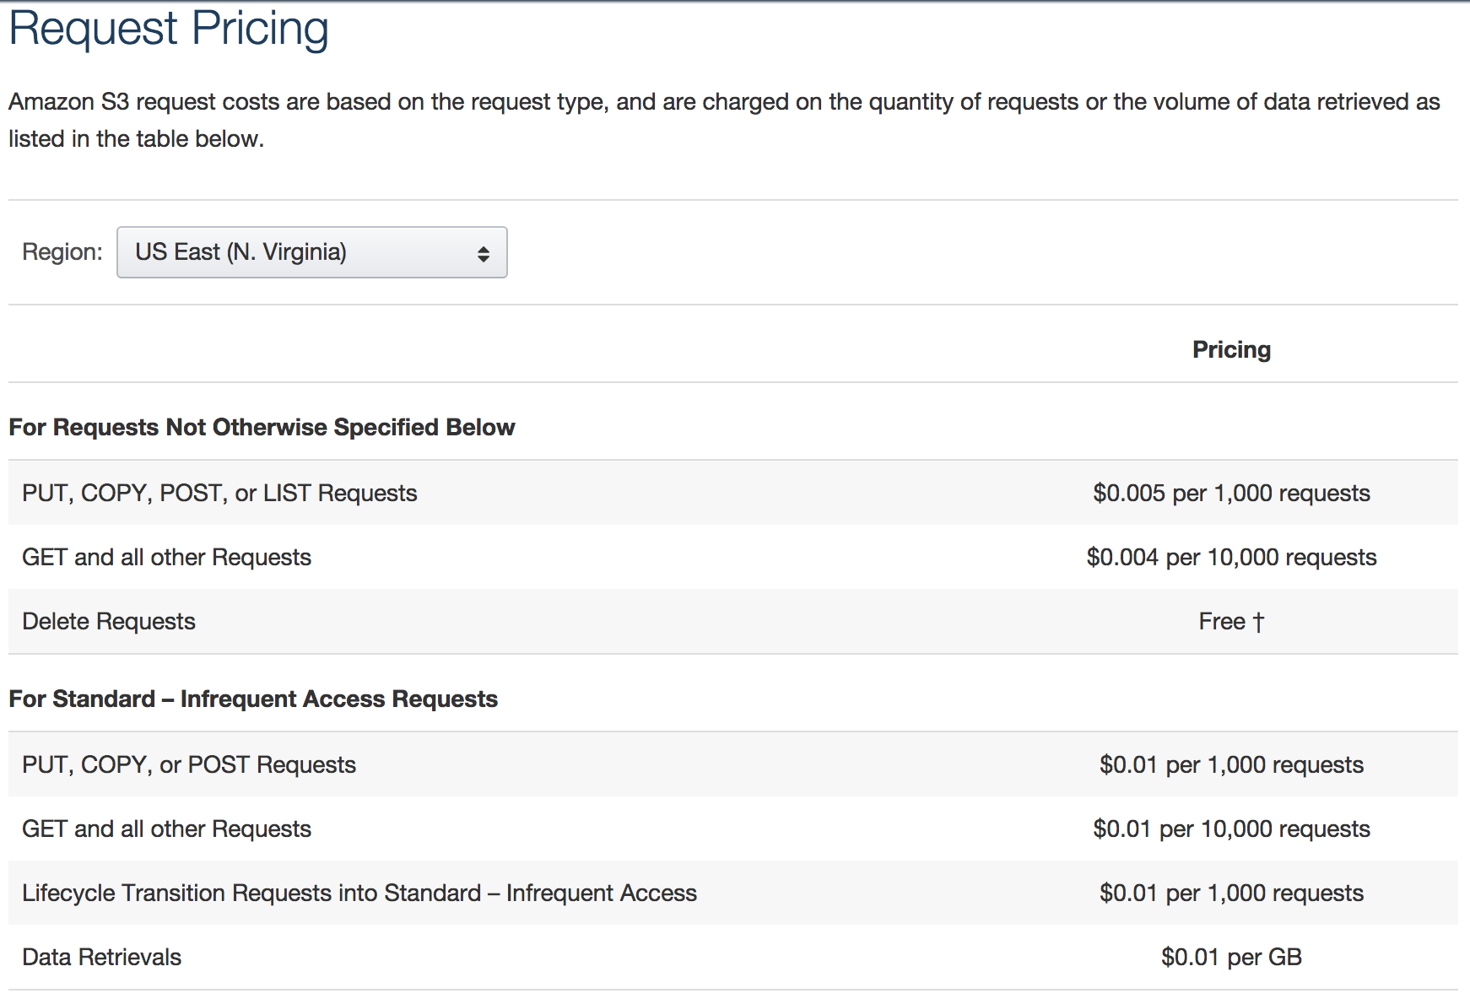

(Source: Cloud Storage Pricing – Amazon Simple Storage Service (S3) – AWS.)

1. **Amazon Rekognition API：90 $/month**

new Amazon Rekognition customers can analyze up to 5,000 images for free each month for the first 12 months.

First 12 months (90000-5000) * 0.001=85 $/month

After 12 months 90000*0.001=90 $/month 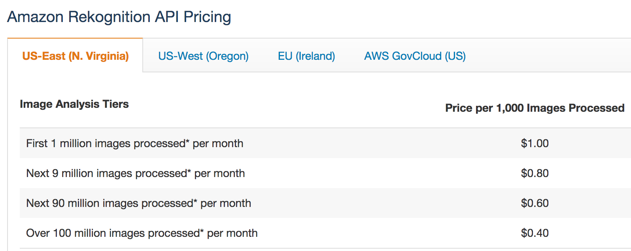

(source: Amazon Rekognition Pricing)

**Cost of Google Cloud API: 133.5 $/month**

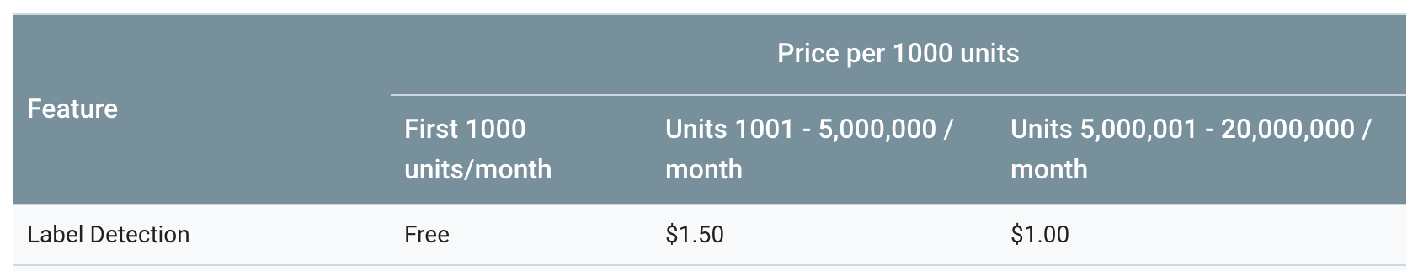

Request number 1000*3*30=90000/month

cost of request on google cloud API: (90000-1000)*1.5/1000=133.5 $/month

**Cost of Nutritionix API: 150 $/month**

The pricing of Nutritionix API : $0.15 user/month

Number of user: 1000

Cost of Nutrition API: 150$/month

**Human and Non-technical costs: 24800 $(one-time)**

**1.cloud engineer(2-person): 70$/hr, 2-week contract**

Task: Implement and deploy the system on AWS. Write functions on lambda to make sure every picture uploaded to our bucket can trigger image rekognition service and call google cloud vision API to automatically return labels and confidential score. After getting all the data, they need to be able to all Nutritionix API and return then return the content of various nutrients for algorithm team to process the data and estimate diet status of a client. (*Glassdoor*.)

**2.Algorithm designer (2-people team):60$/hr, 2-week contract**

Task: Design the algorithm to make full use of data from Nutritionix API and figure out the best calculation method and standard to get a score as accurate as possible to evaluate the diet status of clients.

**3.Front-end system designer (1-person):50$/hr, 2-week contract**

Task: Designing the user interface for the system. UI should make sure to be able to display a chart to show the result of the analyze of their diet status.

**Tax**

(18.97+3.713+90+133.5+150)*7%=27.7$/month

**Total cost**

**Recurring cost every month: $424/month**

**Total cost of building the system: $24,800**

**Conclusion**

With the system that we designed on Amazon Web Service, not only can customers have a better understanding of their diet status but also, UPMC will have access to all the diet data so that they can make some changes to their health care insurance policy and offer reduced health care rates for those who make good lifestyle choices. This incentive-based system, if implemented, encourages people to take a step forward towards improving their health and saving some money at the same time - Eating smart quite literally pays!

**References**

1. Amadeo, Kimberly. “See for Yourself If Obamacare Increased Health Care Costs.” *The Balance*, www.thebalance.com/causes-of-rising-healthcare-costs-4064878.
2. “AWS Lambda - Serverless Compute.” *Amazon Web Services, Inc.*, aws.amazon.com/lambda/?sc_channel=PS.
3. “AWS Lambda – Pricing.” *Amazon Web Services, Inc.*, aws.amazon.com/lambda/pricing/.
4. “Amazon Rekognition Pricing - Amazon Web Services.” *Amazon Web Services, Inc.*, aws.amazon.com/rekognition/pricing/.
5. “AWS vs Azure vs Google Cloud Market Share 2017 - Free Report.” *Skyhigh*, 25 July 2017, www.skyhighnetworks.com/cloud-security-blog/microsoft-azure-closes-iaas-adoption-gap-with-amazon-aws/.
6. “Comparing Image Tagging Services: Google Vision, Microsoft Cognitive Services, Amazon Rekognition and Clarifai • Filestack Blog.” *Filestack Blog*, 1 Sept. 2017, blog.filestack.com/thoughts-and-knowledge/comparing-google-vision-microsoft-cognitive-amazon-rekognition-clarifai/.
7. “Cloud Storage Pricing – Amazon Simple Storage Service (S3) – AWS.” *Amazon Web Services, Inc.*, aws.amazon.com/s3/pricing/.
8. *Google Cloud Vision API Documentation | Google Cloud Vision API Documentation | Google Cloud Platform*, Google, cloud.google.com/vision/docs/.
9. “Here's Why Your Health Insurance Premiums Are Going Up Again.” *The Fiscal Times*, [www.thefiscaltimes.com/2016/05/09/Here-s-Why-Your-Health-Insurance-Premiums-Are-Going-Again.editmore_horiz](http://www.thefiscaltimes.com/2016/05/09/Here-s-Why-Your-Health-Insurance-Premiums-Are-Going-Again.editmore_horiz)
10. “Join for Free in 7 Seconds!” *Nutritionix - Nutrition Database API Documentation*, market.mashape.com/msilverman/nutritionix-nutrition-database.
11. Merhar, Christina. “7 Reasons for Rising Health Care Costs.” Zane Benefits A PeopleKeep Company, 9 May 2014, www.zanebenefits.com/blog/seven-reasons-for-rising-health-care-costs
12. *Meyer, Harris. “Under Health Law, Colonoscopies Are Free – But It Doesn’t Always Work That Way.” Kaiser Health News, 25 Apr. 2011, khn.org/news/health-law-colonoscopy/.*
13. “Overview of Amazon Web Services.” <https://d0.awsstatic.com/whitepapers/aws-overview.pdf>
14. “Salary: Cloud Support Engineer.” *Glassdoor*, [www.glassdoor.com/Salaries/cloud-support-engineer-salary-SRCH_KO0,22.htm](http://www.glassdoor.com/Salaries/cloud-support-engineer-salary-SRCH_KO0,22.htm).
15. “The Daily Shot Brief; June 20 - Global Macro Currents.” *Marketing Automation - Sell More Stuff*, mailchi.mp/dailyshot/the-daily-shot-brief-april-25-global-macro-currents-348293?e=3b53b92804.
16. *UPMC Health Plan | Affordable Insurance for Individuals & Families*, [www.upmchealthplan.com/coverage/find_insurance.aspx](http://www.upmchealthplan.com/coverage/find_insurance.aspx).
17. “What Is Amazon Rekognition?” *What Is Amazon Rekognition? - Amazon Rekognition*, docs.aws.amazon.com/rekognition/latest/dg/what-is.html.

**Appendix**

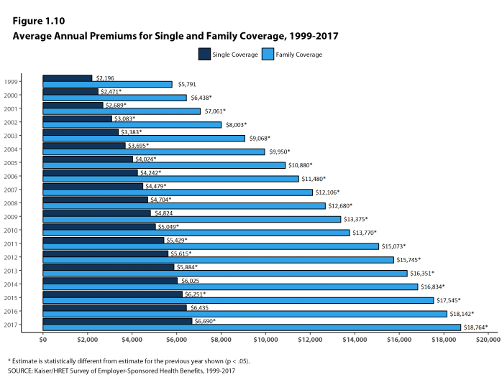

(Figure 1, Source: Henry J. Kaiser Family Foundatio

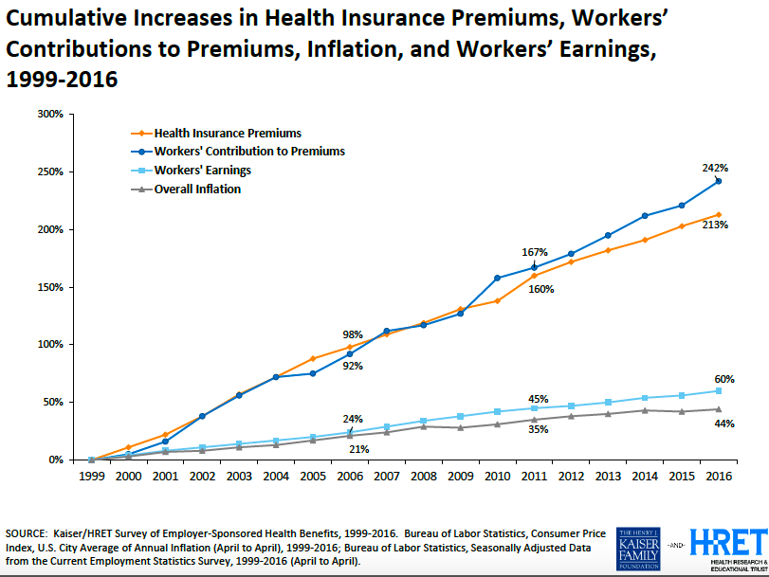

(Figure 2, Source: Henry J. Kaiser Family Foundation)

**Design document**

**1. A detailed description of the system and the needed functionality**

We designed a simulated system on Amazon Web Services that accepts and stores the diet images of customers, and then sends them to Amazon Rekognition, Google Cloud Vision services to analyze and evaluate the client’s lifestyle choices, within an acceptable accuracy. The whole process is triggered once a customer uploads a picture to our website. Through a user interface, the image can be uploaded to our Amazon S3 bucket. From the bucket, we get all the data and send it for image tagging. We get the output in the form of labels for each image. Based on the tags that we get from the image recognition APIs, the algorithm we developed evaluates the client’s lifestyle and shows it on our website to give customers an intuitive feel about their own diet health status.

**2.        A detailed list of the system requirements**

* The system can’t take images larger than 4MB in size.
* An end-to-end system test can be run when the number of images in the public bucket is not too big (to avoid lags).
* Once the prototype is approved, our idea for the actual system would be to capture the images of food consumed by the users through a camera. Our idea is that the camera be worn by the user during the meal - for portability. (Note: This camera does not necessarily have to be worn by the user at all times of the day. Only during meals - 3 to 4 times a day for an average user - would the user start the camera.)
* The system’s image recognition technology is quite solid since there are two Image recognition technologies (and two of the best in the world at that) working independently to generate labels for the images.
* The actual quantity of food consumed is not easy to tell from the image. That is, our system has a drawback in that it can’t differentiate between a user who consumes a huge 1L bottle of soda everyday, and a user who drinks only one glass of soda per day. But the system works **extremely well** when the quantities of different food items are more or less equal to the standard values we(i.e., the Nutritionix API, that reads the labels to generate scores for them) expect.

**3.        Assumptions made for the simulated system**

* The system simulates a scenario where there are input devices worn by users during their meals, that track the diet data. The idea of the original system is to capture images, and identify the type and quality of food taken in by their users. Our simulated system works on a similar dataset. The assumption here is that the images of the user's food are already stored on the cloud (more specifically in an S3 bucket). The analysis and the scoring would be the same as that in the original system (which we shall turn in to UPMC once our pilot prototype is given the green signal).
* The simulated system emulates the camera(that the user is supposed to wear) through another S3 bucket that puts images into the S3 bucket from where the Lambda is triggered.
* Our system assumes that the images that it receives as input are less than 4MB in size. This cap on the maximum size of images is imposed by the image recognition segment of our system which uses Amazon Rekognition and Google Cloud Vision.
* We assume that all the labels with confidence greater than a certain threshold (that we decided on) are correct.
* We evaluate the score for a meal (i.e. image) assuming that the scores returned for the labels from the Nutritionix API are accurate - This is a fair and reasonable assumption. The Nutritionix API is very robust and gives the calories, protein, and other nutritional facts of the labels that it receives.
* Calculating scores without knowing the exact amount of each kind of food item in the image is not possible. We ignore the quantities of items when getting the score. But the technology for calculating the exact quantities of food items based on images is quite complex.

**4.        Architectural design of the proposed system**

* The original system collects (through cameras) images of a user’s meal. This data is put in an S3 bucket. Once an image is put in an S3 bucket, a Lambda event is triggered.
* The Lambda function runs the image through the Rekognition and Google Vision APIs (for detecting the labels).
* **This is the first feature in our system that stands out!** - Two APIs to detect the image labels increases the accuracy by a great degree.
* The output of this Lambda triggers another Lambda function that sends these labels to an API(Nutritionix) to get the individual scores of each of these labels. This score for the meal is computed using various parameters like calories, protein content, etc. from the labels read.
* **This is the second feature in our system that stands out!** - There is NO lookup table that has been manually built to get the scores for the labels. The API is automatically run after generating the labels. It’s much more reliable, accurate, and gives us a scientific basis to generate the user’s score from.
* This is where the cloud part ends. The final score (that is computed through a formula) is sent to the UI part of the system. We currently have pie charts that show the normalised quantities of protein, carbs, sodium, etc. in the meal.
* We have also built a UI that shows the position of the person’s health on a scale ranging from “very unhealthy” to “very healthy”, also recording the deflections in the needle in its “health-o-meter” (caused by the new data). This data can be used to send updates to UPMC regarding the general health of the user, and to give a message to the user about his meal. This UI system shall soon be integrated to our pilot prototype.

**5.**  **Tools, technologies and services that were evaluated, chosen and discarded**

Before choosing the cloud computing platforms, we had to have a few things clear first. Since several clients would upload many images as input, we would need storage services to store all the images so we can do analysis on them. Upon the receipt of new data, our service needs to be triggered automatically and has to start recognizing labels of the images. There is a need for a server and some connection with this storage, therefore. The platform provides servers for us to have the required compute power. Image recognition has to be automatic - Meaning, the system has to be event-triggered! We decided that Lambda was our go-to service. The labels that the recognition part spits out have to be assigned good scores. The algorithm running in the backend to assess the score of the person based on the labels (and their scores) has to be sensitive to the properties of the food taken in. We decided to go with the nutritional facts of the food images as that was a reliable metric. Based on our need, we have done some research on mainstream cloud platform providers in the following aspects:

* **Market share**

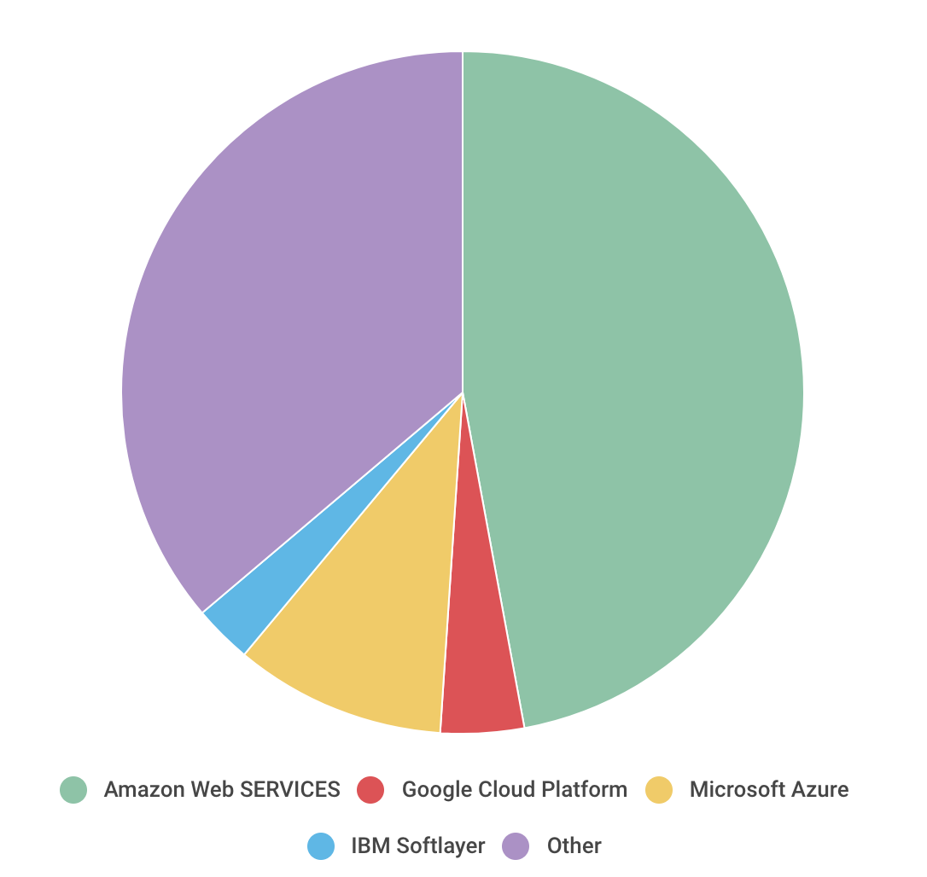

(Source: Comparing Image Tagging Services: Google Vision, Microsoft Cognitive Services, Amazon Rekognition and Clarifai • Filestack Blog)

According to the chart we can see that Amazon Web Services dominates the public cloud market with a [47.1% market share](http://www.businessinsider.com/amazons-cloud-business-hits-over-12-billion-in-revenue-2017-2). While Microsoft Azure is gradually catching up to Amazon, it only holds 10.0% of the market. These two big players are then followed by Google Cloud Platform (3.95%) and IBM Softlayer (2.77%). In terms of revenue, Amazon Web Services has an absolute leading position.

* **Serverless code execution function**

Since we need to run our code on the cloud platform and access the image processing service, we care about the serverless custom code execution as implemented in each cloud platform and the performance of each platform.

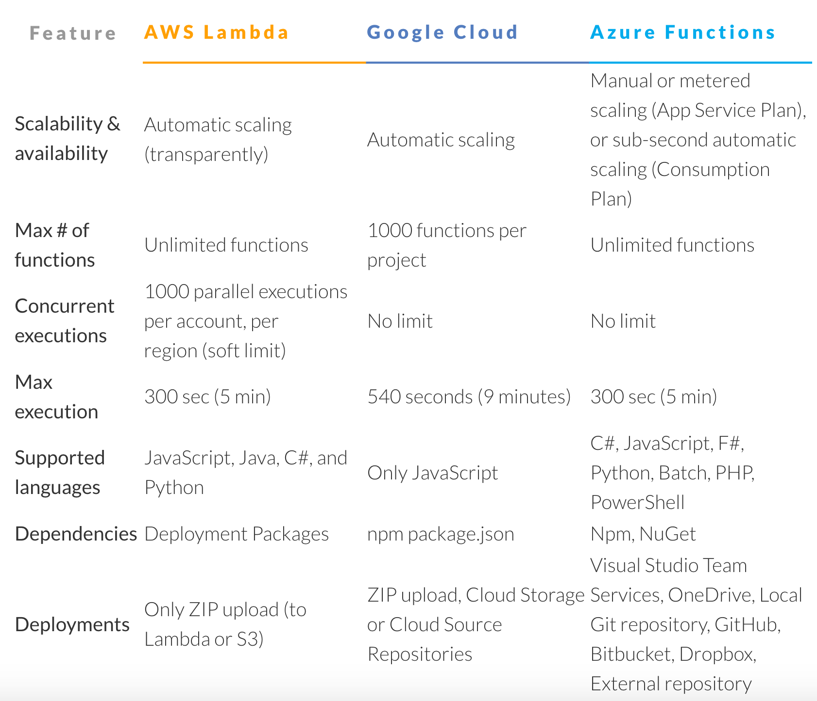



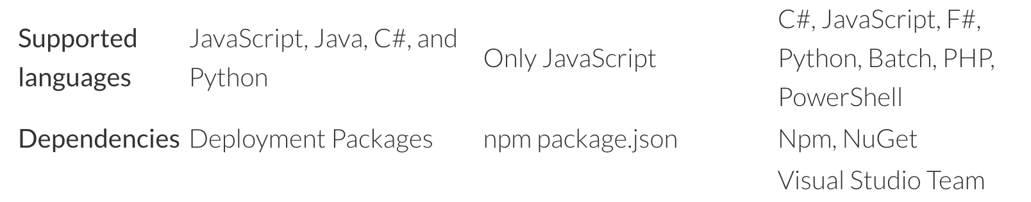

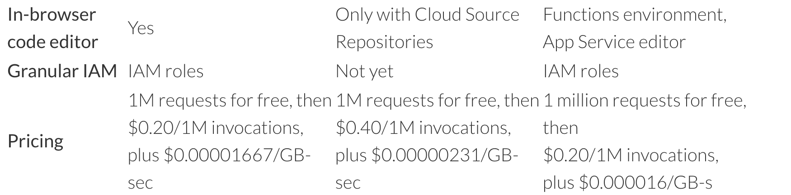

(Source: AWS vs Azure vs Google Cloud Market Share 2017 - Free Report.)

In this chart we get some features of the customer code execution service of the three leading platform. Since GCP cloud function support only Javascript, we decide not to build our system on it and if we need some other function of GCP we can call the api from other platform.

* **Image tagging service**

**-Pricing**

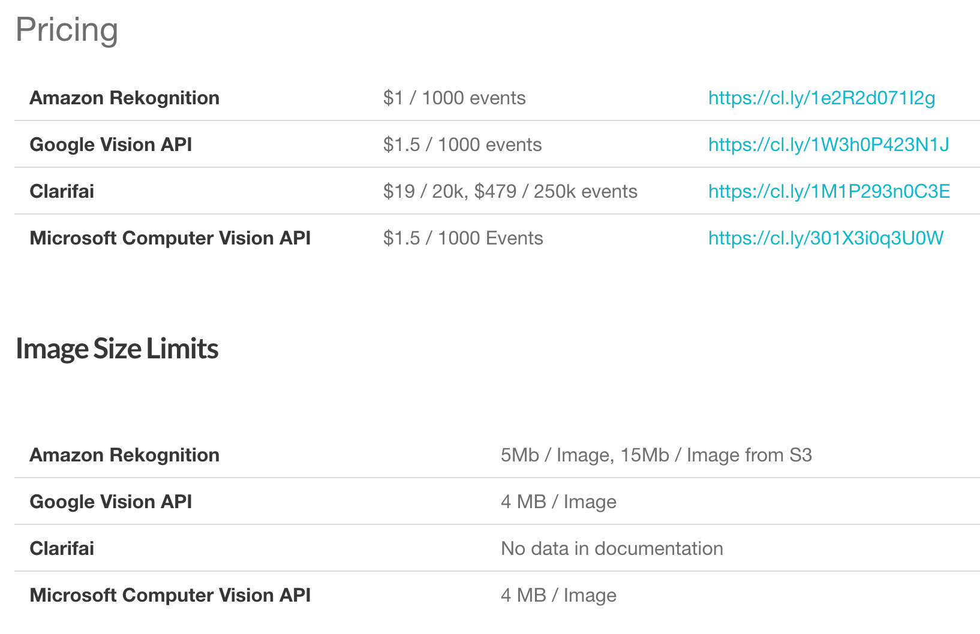

(source: Comparing Image Tagging Services: Google Vision, Microsoft Cognitive Services, Amazon Rekognition and Clarifai • Filestack Blog.)

In terms of price, all of the three platforms provide image tagging service. Since we need to tag we need to compare their price and other index.

In terms of pricing, Amazon rekognition is the most affordable, Google Vision API and Microsoft Computer Vision API have the same price and more expensive. Besides, Only Amazon Rekognition accept 5 Mb per image while Google Vision API and Microsoft Computer Vision API only accept smaller size of image.

**-Accuracy**

On the other hand we need to evaluate the performance of image tagging service of each platform in order to make the results more accurate. We had uploaded pictures to the three platforms to test the performance of their image tagging service.

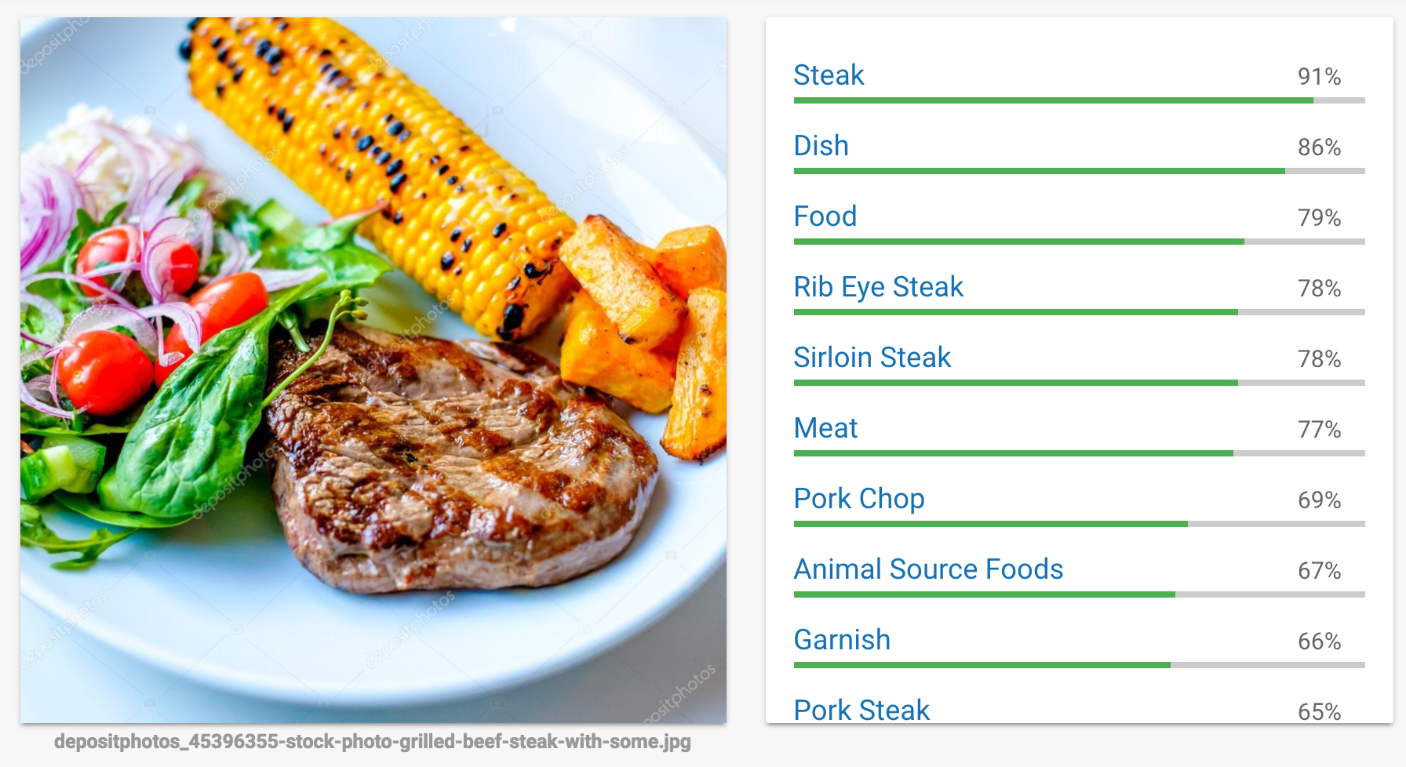Below is the result of Google Vision API:

The result of AWS Rekognition API (left)land Azure computer vision API (right)

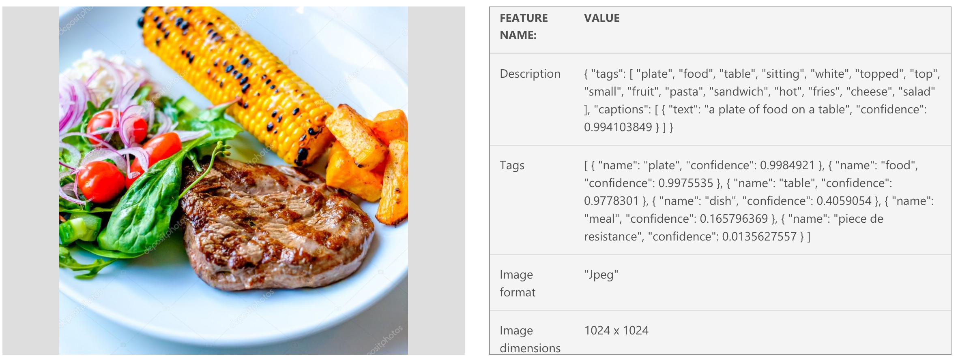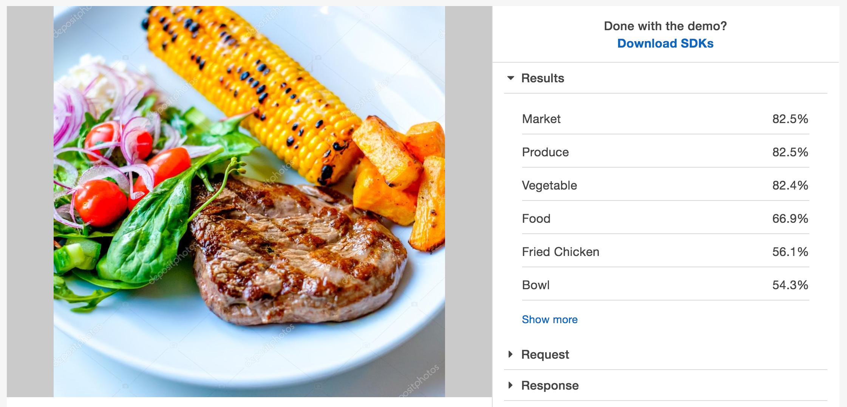

Based on the test result, we can see that Google cloud vision has the highest accuracy. AWS rekognition can distinguish vegetables. However, Azure computer vision API has performed quite inconsistently in recognizing specific ingredients. When we ran the GCP Vision API on 3000 images in the public ebiz bucket (that was given to us for training our model), it returned 1300 labels. Rekognition API, on the other hand, returned about 500 labels for all the 10,000 images in the said bucket. We decided to discard Microsoft Azure because of its inaccuracies in detecting food images. We decided to build our system on AWS lambda and call the Rekognition API and Google cloud Vision APIs to analyze our images and get more accurate results.

**6.        Realistic scenarios under which to carry out an end-to-end test of the system**

* We could start with a small set of users (suppose it to be 1000) for a while after we go live. This is the phase where we fix bugs, ensure the accuracy, etc. Then over a period of a couple of months, we scale it to accommodate all of UPMC’s users.
* This camera takes pictures of food once every 30 second and transmits it to an S3 bucket (storage system) in the cloud. This is to ensure that there are no discrepancies (which will be very few) in the image labels being read.

**7.        Outline tools, technologies and cloud services needed**

* Cloud technologies used: S3 buckets, Lambda service, Rekognition, Google Cloud Vision
* Other tools and technologies: Nutritionix package for getting scores for the image labels, and UI.